PhD Studentship in Particle Physics Phenomenology at the NExT Institute

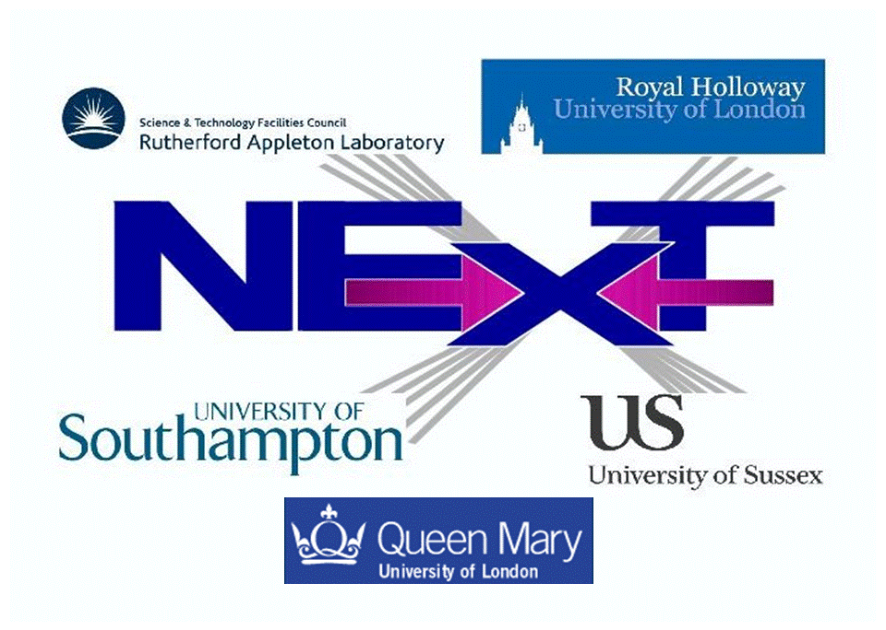

The NExT Institute (http://www.next-institute.ac.uk), a partnership involving the University of Southampton, the STFC Rutherford Appleton Laboratory (RAL), Queen Mary University of London (QMUL), Royal Holloway University of London (RHUL) and the University of Sussex, is offering one 4-year PhD studentship in particle physics phenomenology.

The Institute proposes a project on the physics of neutrinos, involving phenomenological (ie, at the interface between theory and experiment) work within the Deep Underground Neutrino Experiment (DUNE) located in the USA. This is an international collaboration seeking to understand the properties of the most abundant matter particles in the Universe, specifically, how they acquire mass, a phenomenon that has remained unexplained in Nature following the Nobel Prize in Physics 2015 indeed awarded "for the discovery of neutrino oscillations, which shows that neutrinos have mass”. In fact, there is also a significant Data Acquisition (DAQ) component to the project, since the UK is a major player in the design and delivery of the DAQ system for the DUNE experiment. This system is a major software challenge and will use sophisticated software engineering techniques. The student will then work on this system which will be deployed initially on ProtoDUNE at CERN. The student will also work on data analysis at the ProtoDUNE facility and towards developing the DUNE experiment's capability for detecting Dark Matter (DM) trapped in the sun.
The studentship will be organised as follows.

- The main purpose of this studentship is to provide an opportunity to carry out research to PhD level on topics in particle physics phenomenology in the area of neutrino (and DM) physics.
- Training and research will be part of a novel PhD programme developed in the context of the NExT Institute. This will involve mixed (theoretical and experimental) training and joint/shared supervision, networking across nodes, video-linked delivery of seminars and graduate lectures as well as an annual residential workshop plus regular scientific meetings. Attendance to the London Intercollegiate Postgraduate Course in Elementary Particle Physics is also foreseen.

- The student will also undergo training on data intensive science via the DISCnet programme. The DISCnet training additionally involves two 3-month placements in local data science industrial partners or non-profit organisations.
- The student will formally be enrolled with both QMUL and the University of Southampton, thus he/she will need to satisfy the entry requirements of and apply to both universities by adopting the procedures described at the two following webpages:
http://pprc.qmul.ac.uk/postgraduate/phd-programme/
http://www.hep.phys.soton.ac.uk/opportunities/
- The ultimate deadline for both applications is 6 September 2020 but early submissions are strongly encouraged and interviews will be arranged straight after so that the position will be filled as soon as a suitable candidate will be identified on a first come first serve basis.
- The studentship also has a supervisory component at the Particle Physics Department (PPD) in RAL.
- The student will tentatively spend the first year of the studentship at Southampton and the remainder at QMUL and RAL, including stays at CERN on ProtoDUNE, but this will be defined in due course.
- The studentship will start at the end of September 2020 and stop at the end of September 2024. The student will be issued with a joint PhD award from the two universities involved. Financial support will be provided by QMUL, RAL and the University of Southampton.
- The student will receive UK/EU fees (currently £ 4,407) plus a yearly stipend of £15,285 and London weighting of £2,000/year (pro rata) when based at QMUL, for 4 years.
- In addition, a Research Training Support Grant (RTSG) will be awarded for travel and subsistence within and outside the Institute, including a long Term Attachment (LTA) element, ie, a fieldwork component to visit DUNE facilities (at CERN and/or in the US).

Informal contact can be established with Prof. Stefano Moretti (S.Moretti@soton.ac.uk), Prof. Claire H. Shepherd-Themistocleous (Claire.Shepherd@stfc.ac.uk) and Dr. Linda Cremonesi (L.Cremonesi@qmul.ac.uk).

