PhD Studentship in Particle Physics Phenomenology at the NExT Institute

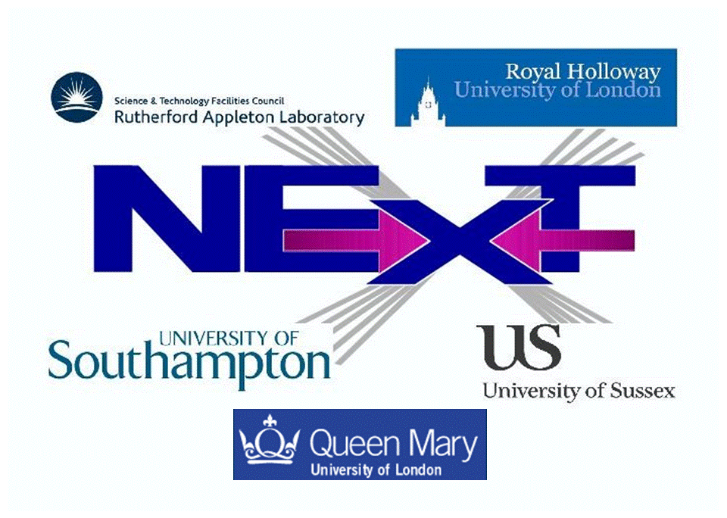

The NExT Institute (http://www.next-institute.ac.uk), a partnership involving the University of Southampton, the STFC Rutherford Appleton Laboratory (RAL), Queen Mary University of London (QMUL), Royal Holloway University of London (RHUL) and the University of Sussex, is offering one PhD studentship in particle physics phenomenology.

The Institute promotes work at the interface between theory and experiment and the research project for this position is entitled “Nu Connections between Theory and Experiment (NuExT)”. This project will focus on studying the capability of Hyper-Kamiokande (HK) and its complementarity to other long baseline neutrino experiments, in excluding or restricting the parameter space of various theoretical models capable of predicting the value of the leptonic CP violating phase, as well as the other lepton mixing angles, which will be studied in order to make the case for such facilities and define the necessary parameters of the experiment.
Financial support is provided by QMUL and the University of Southampton. The studentship will be funded for 3 years at approximately 50% FTE (the rest provided by the applicant) as follows:
- The student will receive UK/EU fees (currently around £4,121) plus a yearly stipend of (initially) around £14,296 and London weighting of £2,000/year (pro rata) when based at QMUL.
- In addition, a research training support grant of £1,200 per year will be awarded for travel and subsistence within and outside the Institute.
- The main purpose of this studentship is to provide an opportunity to carry out research to PhD level on topics in particle physics phenomenology in the area of neutrino physics. The student would become part of the HK experiment.
- Training and research will be part of a novel PhD programme developed in the context of the NExT Institute. This will involve mixed (theoretical and experimental) training and joint/shared supervision, networking across all nodes, video-linked delivery of seminars and graduate lectures and an annual workshop. Attendance to the London Intercollegiate Postgraduate Course in Elementary Particle Physics is also foreseen.
- The student will formally be enrolled with both QMUL and the University of Southampton, thus he/she will need to satisfy the entry requirements of and apply to both universities by adopting the procedures described at the two following webpages:

http://pprc.qmul.ac.uk/postgraduate/phd-programme/
http://www.hep.phys.soton.ac.uk/opportunities/

- The deadline for both applications is 30 April 2016. Early submissions are encouraged.
- The student will tentatively spend the first half of the studentship at Southampton and the second half at QMUL.
- The studentship will start at the beginning of October 2016 and stop at the end of September 2019. The student will be issued with a joint PhD award from the two institutions involved.
Informal contact can also be established at Southampton with Prof SF King (sfk@soton.ac.uk) and at QMUL with Prof F Di Lodovico (f.di.lodovico@qmul.ac.uk).

