Joint Bristol/Southampton PhD Studentship in Particle Physics Phenomenology at the NExT Institute

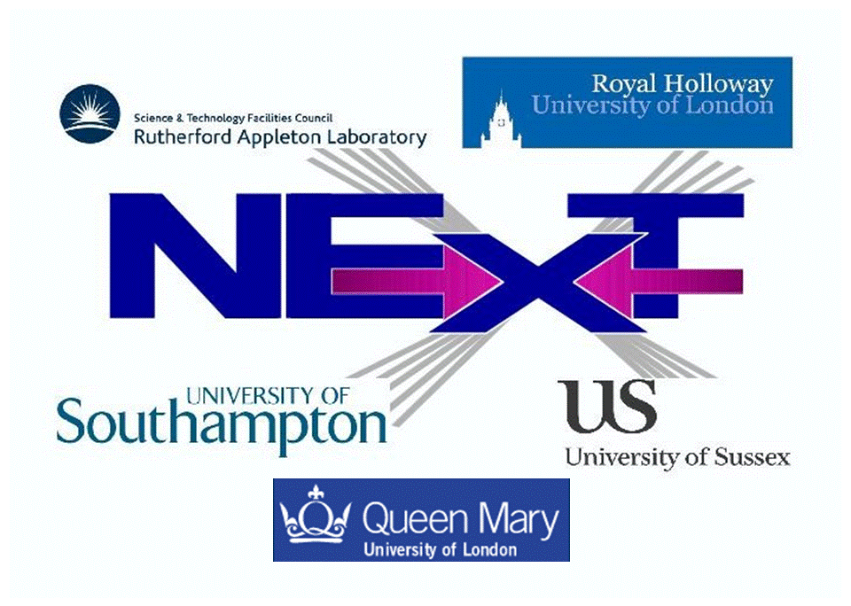

The Experimental Particle Physics group at the University of Bristol and the High Energy Physics Group at the University of Southampton are offering one PhD position in collider phenomenology. The training and research associated to this position will take place within the NExT Institute (http://www.next-institute.ac.uk). This is a partnership involving the University of Southampton, the STFC Rutherford Appleton Laboratory (RAL), Queen Mary University of London (QMUL), Royal Holloway University of London (RHUL) and the University of Sussex, with the University of Bristol being an associate node.
The Institute promotes work at the interface between theory and experiment and the project for this position is entitled “Amplitude analyses for precision flavour physics”. The focus of the studentship would be on the reduction of the theory uncertainty of amplitude models, using new approaches in amplitude analyses and sophisticated amplitude models, developed in close collaboration between experimentalists and theorists.
Financial support is provided by the Universities of Bristol and Southampton. The studentship will be funded for 3 years at 50% FTE (the applicant providing the remainder) as follows:
- The student will receive UK/EU fees (currently around £4,121) plus a yearly stipend of (initially) around £14,296.
- In addition, a research training support grant of £1,200 per year will be awarded for travel and subsistence within and outside the Institute.
- The main purpose of this studentship is to provide an opportunity to carry out research to PhD level on topics in particle physics phenomenology at the LHC. The student will be part of the LHCb experiment.
- Training and research will be part of a novel PhD programme developed in the context of the NExT Institute. This will involve mixed (theoretical and experimental) training and joint/shared supervision, networking across all nodes, video-linked delivery of seminars and graduate lectures and an annual workshop.
- The student will formally be enrolled with both Bristol and Southampton, thus he/she will need to satisfy the entry requirements of and apply to both universities by adopting the procedures described at the two following webpages:
http://www.bristol.ac.uk/physics/courses/postgraduate/
http://www.hep.phys.soton.ac.uk/opportunities/
- The deadline for both applications is 31 March 2016.
- The student will tentatively spend the first half of the studentship at Southampton and the second half at Bristol. Extended stays at CERN are foreseen.
- The studentship will start at the beginning of October 2016 and stop at the end of September 2019. The student will be issued with a joint PhD award from the two universities involved.
Informal contact can also be established at Southampton with Profs. Stefano Moretti (stefano@soton.ac.uk) or Jonathan M Flynn (jmf@soton.ac.uk) and at Bristol with Dr. Jonas Rademacker (jonas.rademacker@bristol.ac.uk).

