PhD Studentship in Particle Physics Phenomenology at the NExT Institute

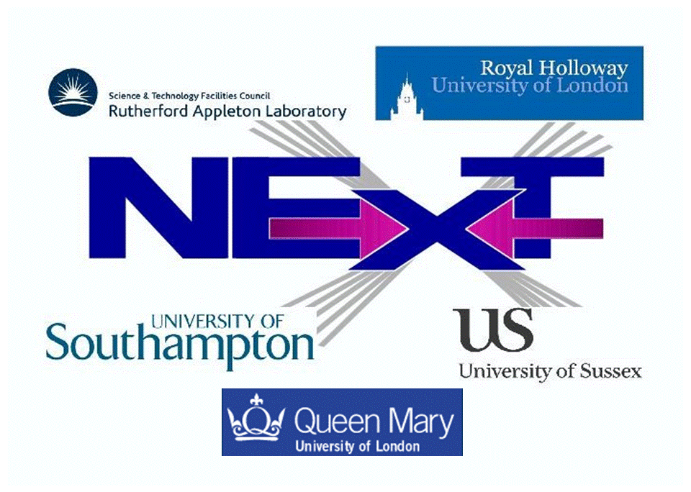

The NExT Institute (http://www.next-institute.ac.uk), a partnership involving the University of Southampton, the STFC Rutherford Appleton Laboratory (RAL), Queen Mary University of London (QMUL), Royal Holloway University of London (RHUL) and the University of Sussex, is offering one PhD studentship in particle physics phenomenology.
The Institute promotes work at the interface between theory and experiment and the research project for this position is entitled “SM tests and BSM searches in final states with b-quarks and tau leptons at the LHC”. This project will focus on defining new observables in order to exploit the LHC potential in measuring the couplings between the discovered Higgs boson and fermions and in searches for new (pseudo)scalar particles.
Financial support is provided by QMUL and the University of Southampton. The studentship will be funded for 3 years as follows:
- The student will receive UK/EU fees (currently around £4,300) plus a yearly stipend of (initially) around £15,000 and London weighting of £2,200/year (pro rata) when based at QMUL.
- In addition, a research training support grant of £1,200 per year will be awarded for travel and subsistence within and outside the Institute.
- The main purpose of this studentship is to provide an opportunity to carry out research to PhD level on topics in particle physics phenomenology in the area of Higgs physics. The student would become part of the ATLAS experiment.
- Training and research will be part of a novel PhD programme developed in the context of the NExT Institute. This will involve mixed (theoretical and experimental) training and joint/shared supervision, networking across all nodes, video-linked delivery of seminars and graduate lectures and an annual workshop. Attendance to the London Intercollegiate Postgraduate Course in Elementary Particle Physics is also foreseen.
- The student will formally be enrolled with both QMUL and the University of Southampton, thus he/she will need to satisfy the entry requirements of and apply to both universities by adopting the procedures described at the two following webpages:

http://pprc.qmul.ac.uk/postgraduate/phd-programme/
http://www.hep.phys.soton.ac.uk/opportunities/

- The deadline for both applications is 30 April 2015. Early submissions are encouraged.
- The student will tentatively spend the first half of the studentship at Southampton and the second half at QMUL.
- The studentship will start at the beginning of October 2015 and stop at the end of September 2018. The student will be issued with a joint PhD award from the two institutions involved.
Informal contact can also be established at Southampton with Dr. Elena Accomando (e.accomando@soton.ac.uk) and at QMUL with Dr. Jonathan Hays (j.hays@qmul.ac.uk).

