Joint Bristol/Southampton PhD Studentship in Particle Physics Phenomenology at the NExT Institute

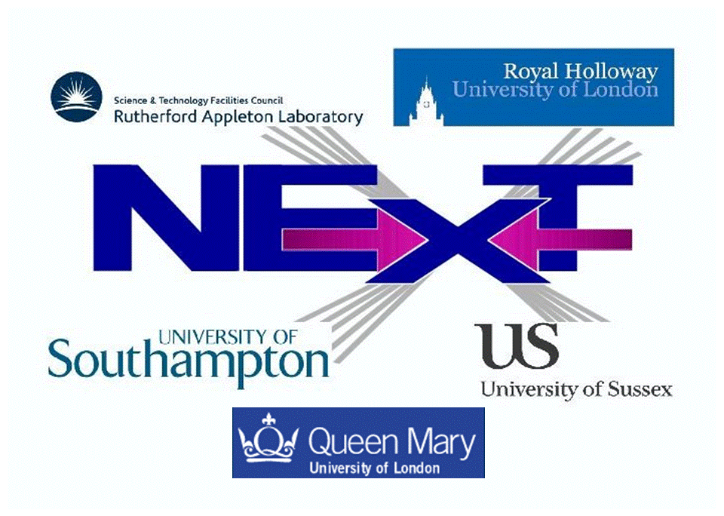

The Experimental Particle Physics group at the University of Bristol and the High Energy Physics Group at the University of Southampton are offering one PhD position in collider phenomenology. The training and research associated to this position will take place within the NExT Institute (http://www.next-institute.ac.uk). This is a partnership involving the University of Southampton, the STFC Rutherford Appleton Laboratory (RAL), Queen Mary University of London (QMUL), Royal Holloway University of London (RHUL) and the University of Sussex, with the University of Bristol being an associate node.
The Institute promotes work at the interface between theory and experiment and the project for this position is entitled “Beyond the Standard Model Physics at CMS”. This project will focus on extracting Higgs signals within the Next-to-Minimal Supersymmetric Standard Model (NMSSM) from cascade decays of Supersymmetric particles searched for by the CMS experiment.
Financial support is provided by the Universities of Bristol and Southampton as well as RAL. The studentship will be funded for 3 years as follows:
- The student will receive UK/EU fees (currently around £4,200) plus a yearly stipend of (initially) around £14,600.
- In addition, a research training support grant of £1,200 per year will be awarded for travel and subsistence within and outside the Institute.
- The main purpose of this studentship is to provide an opportunity to carry out research to PhD level on topics in particle physics phenomenology at the Large Hadron Collider (LHC).
- Training and research will be part of a novel PhD programme developed in the context of the NExT Institute. This will involve mixed (theoretical and experimental) training and joint/shared supervision, networking across all nodes, video-linked delivery of seminars and graduate lectures and an annual workshop.
- The student will formally be enrolled with both Bristol and Southampton, thus he/she will need to satisfy the entry requirements of and apply to both universities by adopting the procedures described at the two following webpages:
http://www.bristol.ac.uk/physics/courses/postgraduate/
http://www.hep.phys.soton.ac.uk/opportunities/
- The deadline for both applications is 31 March 2014.
- The student will tentatively spend the first half of the studentship at Southampton and the second half at Bristol. Regular visits to RAL will also occur. Extended stays at CERN are foreseen too.
- The studentship will start at the beginning of October 2014 and stop at the end of September 2017. The student will be issued with a joint PhD award from the two universities involved.
Informal contact can also be established at Southampton with Prof. Stefano Moretti (stefano@soton.ac.uk), at Bristol with Dr. Henning Flaecher (henning.flacher@cern.ch) and at RAL with Dr. Claire Shepherd (claire.shepherd@stfc.ac.uk).

